Anthony Bugatto

Image Analysis

Homework 1

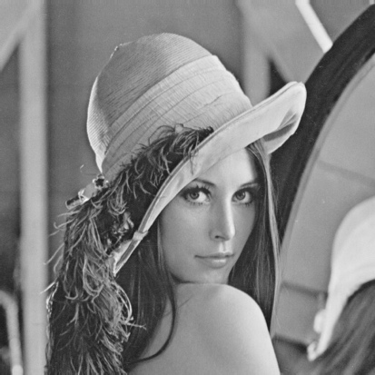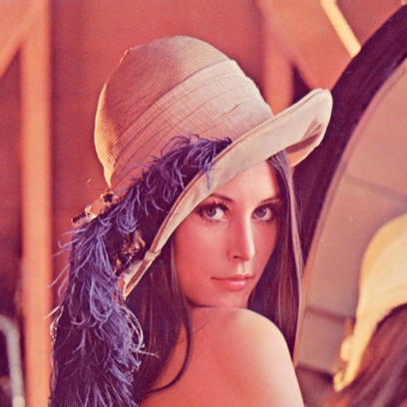

Figure 1: Lena from color to grayscale

* 1. Starting with a Lena color image I used a luminosity method to convert to grayscale (figure 1). The luminosity method acts as a more revealing way to create grayscale images because the values of each r, g, and b pixel are weighted such that the human eye color sensitivity is taken into consideration. I used weights of .11 for blue, .59 for red, and .3 for green.

Figure 2: Down sampled pyramid of grayscale Lena images

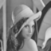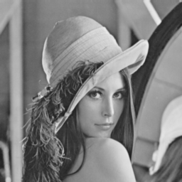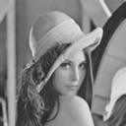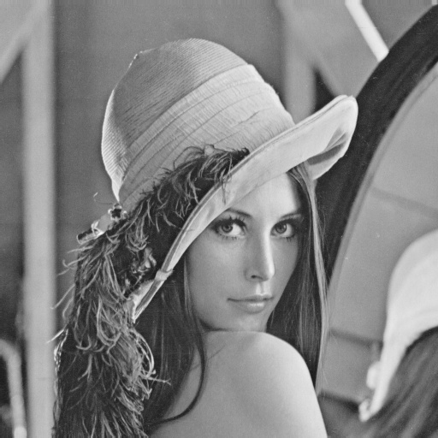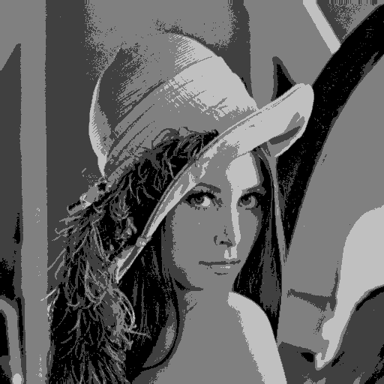

Figure 3: Quantized Lena (4 bins)

* 1. Using the grayscale image from part a and finding a 3x3 Gaussian kernel I down sampled three times successively to get the images in figure 2.
  2. Using the grayscale Lena image from part a I quantized the image into 4 colors (figure 3).

1. 1. OpenCV is not very suited for plotting histograms so it took m e a long time to figure out how to make it work.

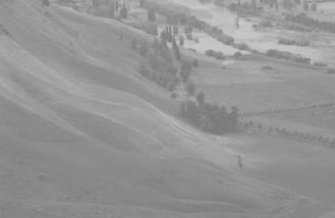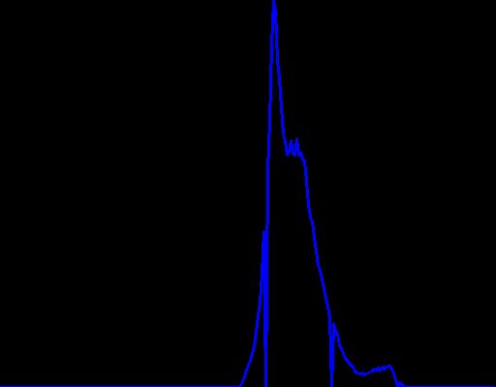

Figure 4: Valley picture and histogram

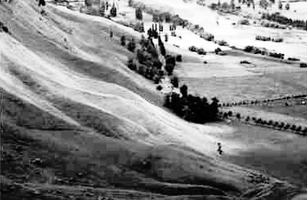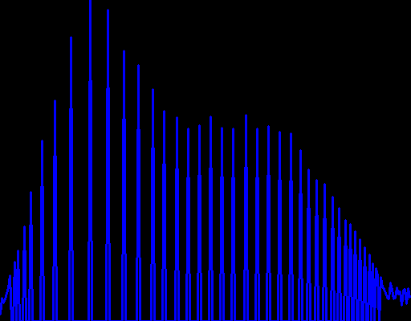

Figure 5: Equalized valley picture and equalized histogram

* 1. Figure 6 and figure 7

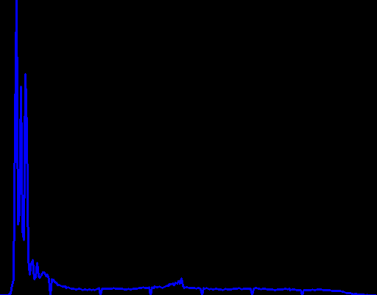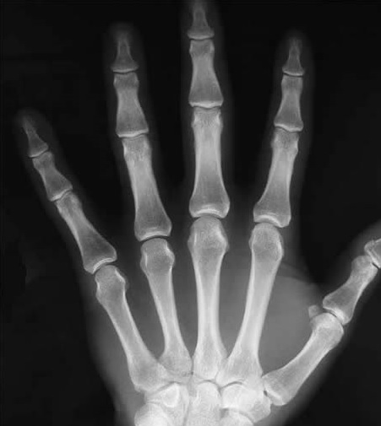

Figure 6: X-ray image and histogram

1. figurses 8 and 9 which reveals a rabbit

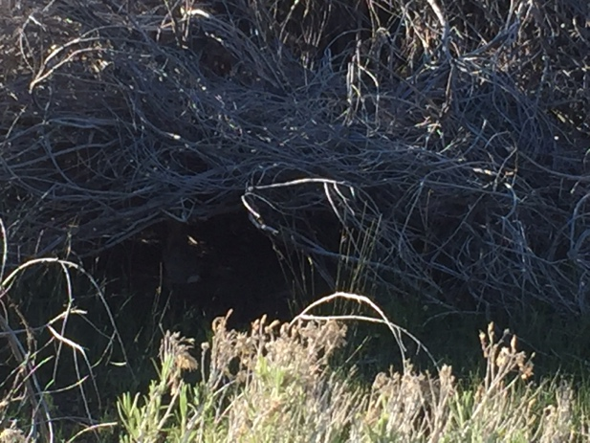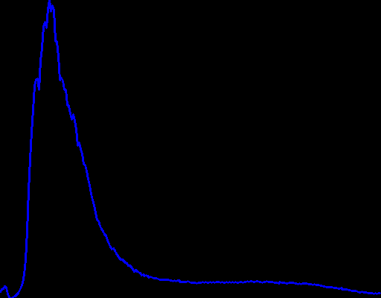

Figure 8: Nature picture and histogram of grayscaled version

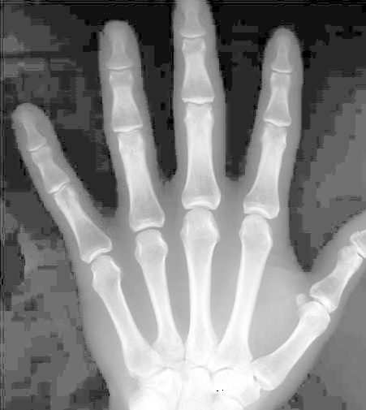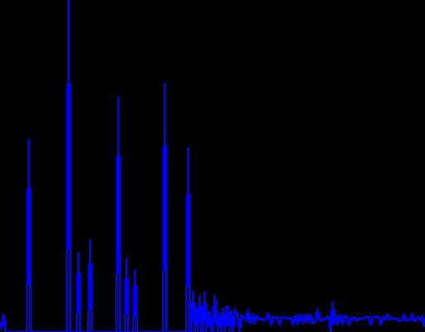

Figure 7: Equalized X-ray image and equalized histogram

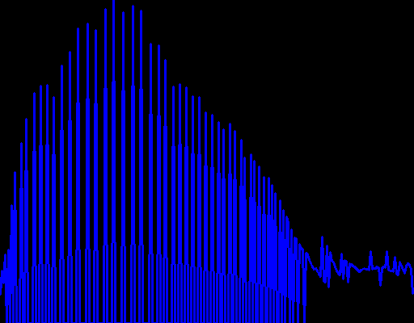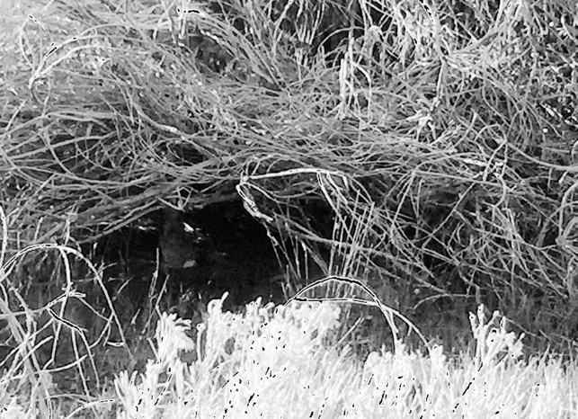

Figure 9: Equalized Grayscale Nature picture and equalized grayscaled histogram